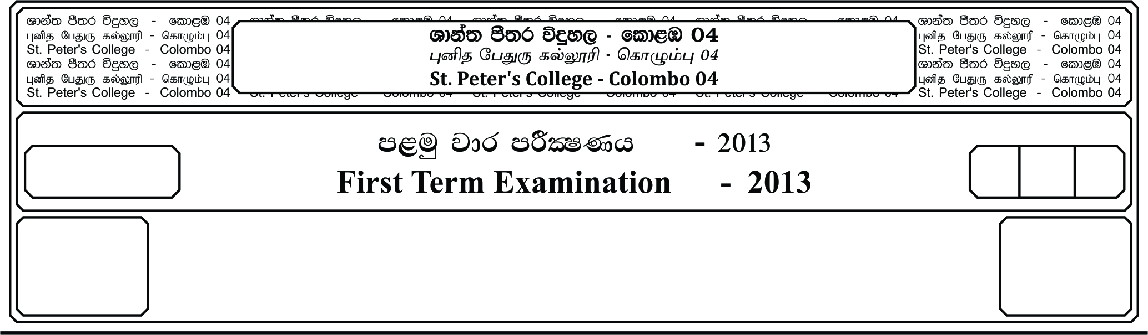

12 fY%aKsh

GRADE 12

E

meh 02

02 Hour

I

**fojk jdr mÍCIKh - 2019**

**Second Term Examination - 2019**

;¾l Ydia;%h yd úoHd;aul l%uh - »»

**LOGIC & SCIENTIFIC METHOD – II**

24

● **Answer four questions only.**

01. i. Fill in the blanks writing in the each case the correct term out of the three terms true,

fales, indeterminable (considering truth value)

a). When ‘Some crows are black’ is it true, ‘All crows are black’ is ………………………...

b). When ‘All crows are black’ is false, ‘No crow is black’ is ………………………...

c). When ‘All crows are not balck’ false, ‘No crow is black’ is ………………………...

d). When ‘No crow is black’ is false, ‘Some crows are black’ is ………………………...

e). When ‘Some crows are not black’ is true, ‘No crow is black’ is ………………………...

**(05 Marks)**

ii. Determine whether the following arguments are valid or invalid by the methods of

eduction. When the argument is invalid state the fallacy involved.

a). Some fruits are not expensive.

Therefore somethings which are expensive are not fruits.

b). All horses run fast.

Therefore no horses does not run fast.

c). Some dogs don’t bark.

Therefore some ones which do not bark are dogs.

d). Some men are tall.

Therefore some men are not-tall.

e). No crow is white.

Therefore some which are not crows are white. **(10 Marks)**

02. i. Determine whether the following syllogisms are valid or invalid. When the argument is

invalid state the rule/rules violated and name the resulting fallacy/fallacies.

a). No painter is a scientist.

Some poets are painters.

Therefore some poets are painters.

b). Only men are wise.

Only the wise are lucky.

Therefore only men are lucky.

c). All intelligents are philosophers, because all kings are phiylosophers and all intelligents

are powerful.

d). Citizens are not rulers, for some citizens are not educated and all rulers are educated.

e). Since Aristotle is both philosophers and a scientist, a philosopher is a scientist.

**(3×5=15 Marks)**

03. i. Symbolize the following arguments in terms of classes and determine their validity

using Venn diagrams.

a). All animals run fast.

Tiger is an animal.

Therefore Tiger runs fast.

b). Aristotle is a philosopher.

Aristotle is an intellectual.

Therefore intellectuals are philosophers.

c). Vegetables are expensive because expensive things are rare and vegetables are rare.

**(3×3=9 Marks)**

ii. Write short notes on the following.

a). Class Union

b). Class Intersection **(3×2=6 Marks)**

04. i. Briefly explain Popper’s demarcation principle. **(05 Marks)**

ii. Explain following topics briefly.

a). Logic as a formal science.

b). Logic as a abstract science. **(2 ½ × 2 = 5 Marks)**

iii. Convert the following to categorical form.

a). Pigs don’t fly.

b). Only women screm like that.

c). No one can wear those caps other than Policeman.

d). All the educated are not intelligent.

e). Intelligent ones are lucky.

05. i. Write short notes with examples on the following.

a). Simple proposition.

b). Symmectric proposition.

c). Law of excluded middle.

d). Formal science and informal science.

e). Analytic and synthetic propositions. **(3×5=15 Marks)**